# Lich - Ossa Amet(raspberry bones)

Old English word lich = Lic  
  
Horns on head, messy tangled raspberry horns. One side like Leshen Art 5ish prongs, other side 2-3ish prongs. Horns are raspberry branches tangled up. Using the old meaning of Lich. Specifically the very old undead rather than a necromancer.

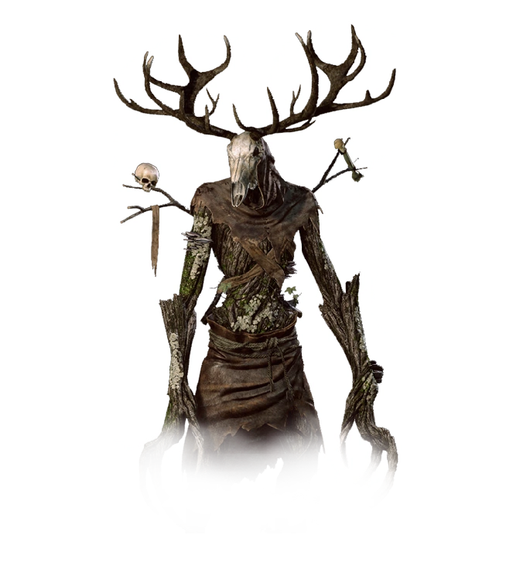

* Lich has “skin” more bark appearance than skin. Its body looks emaciated to the point it’s almost completely skeletal. Parts are completely disconnected (EX, an arm is no longer connected to the body and either held in place by seemingly nothing, or a barely visible transparent color (Such as silver) bridging the gap between severed limb and stump.

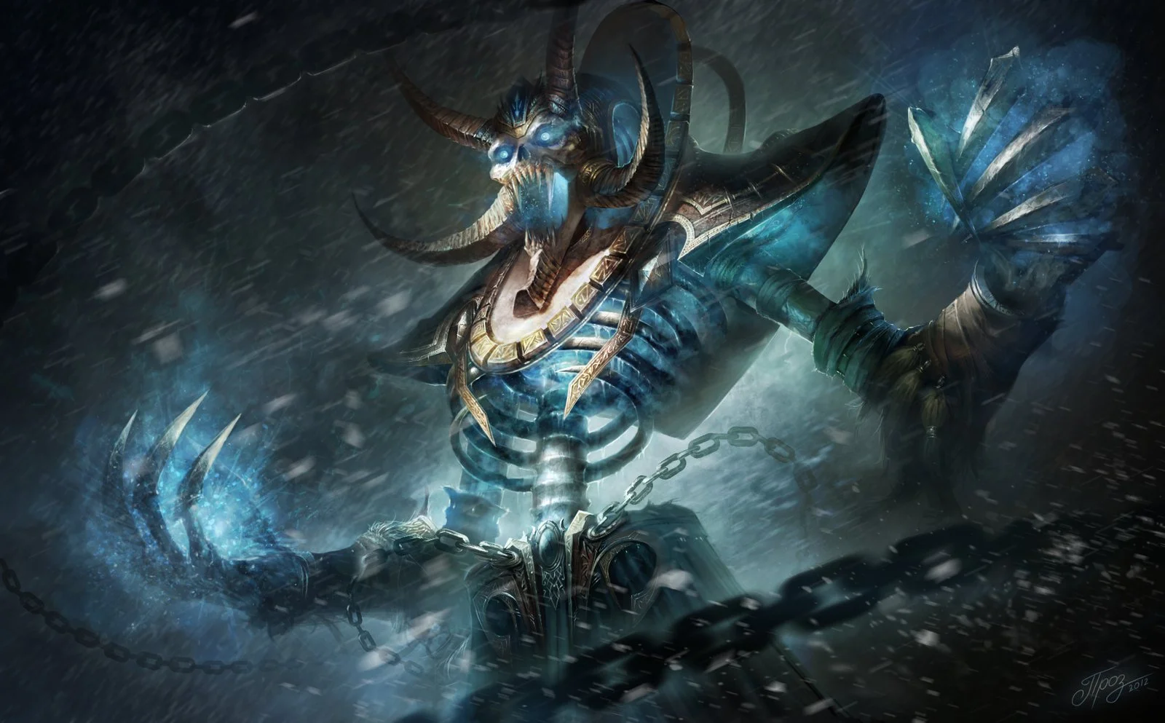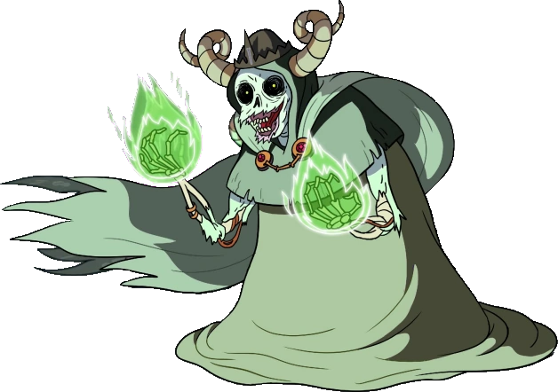  
  
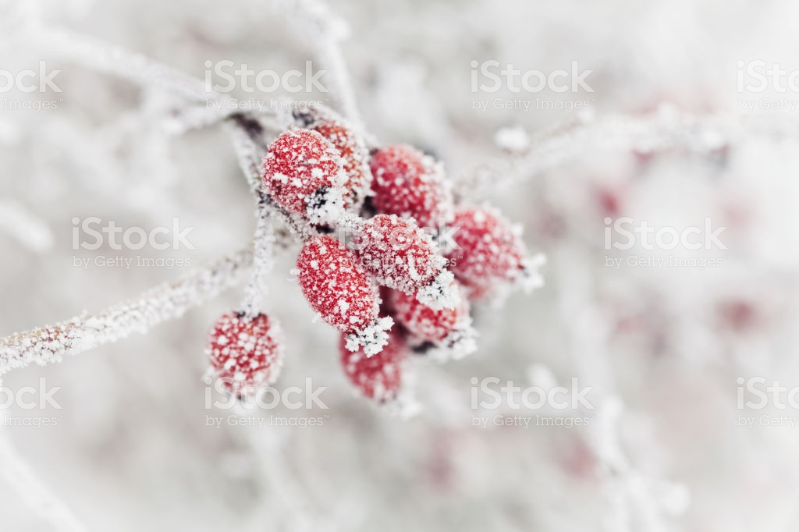

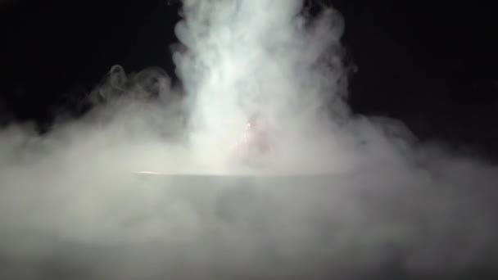

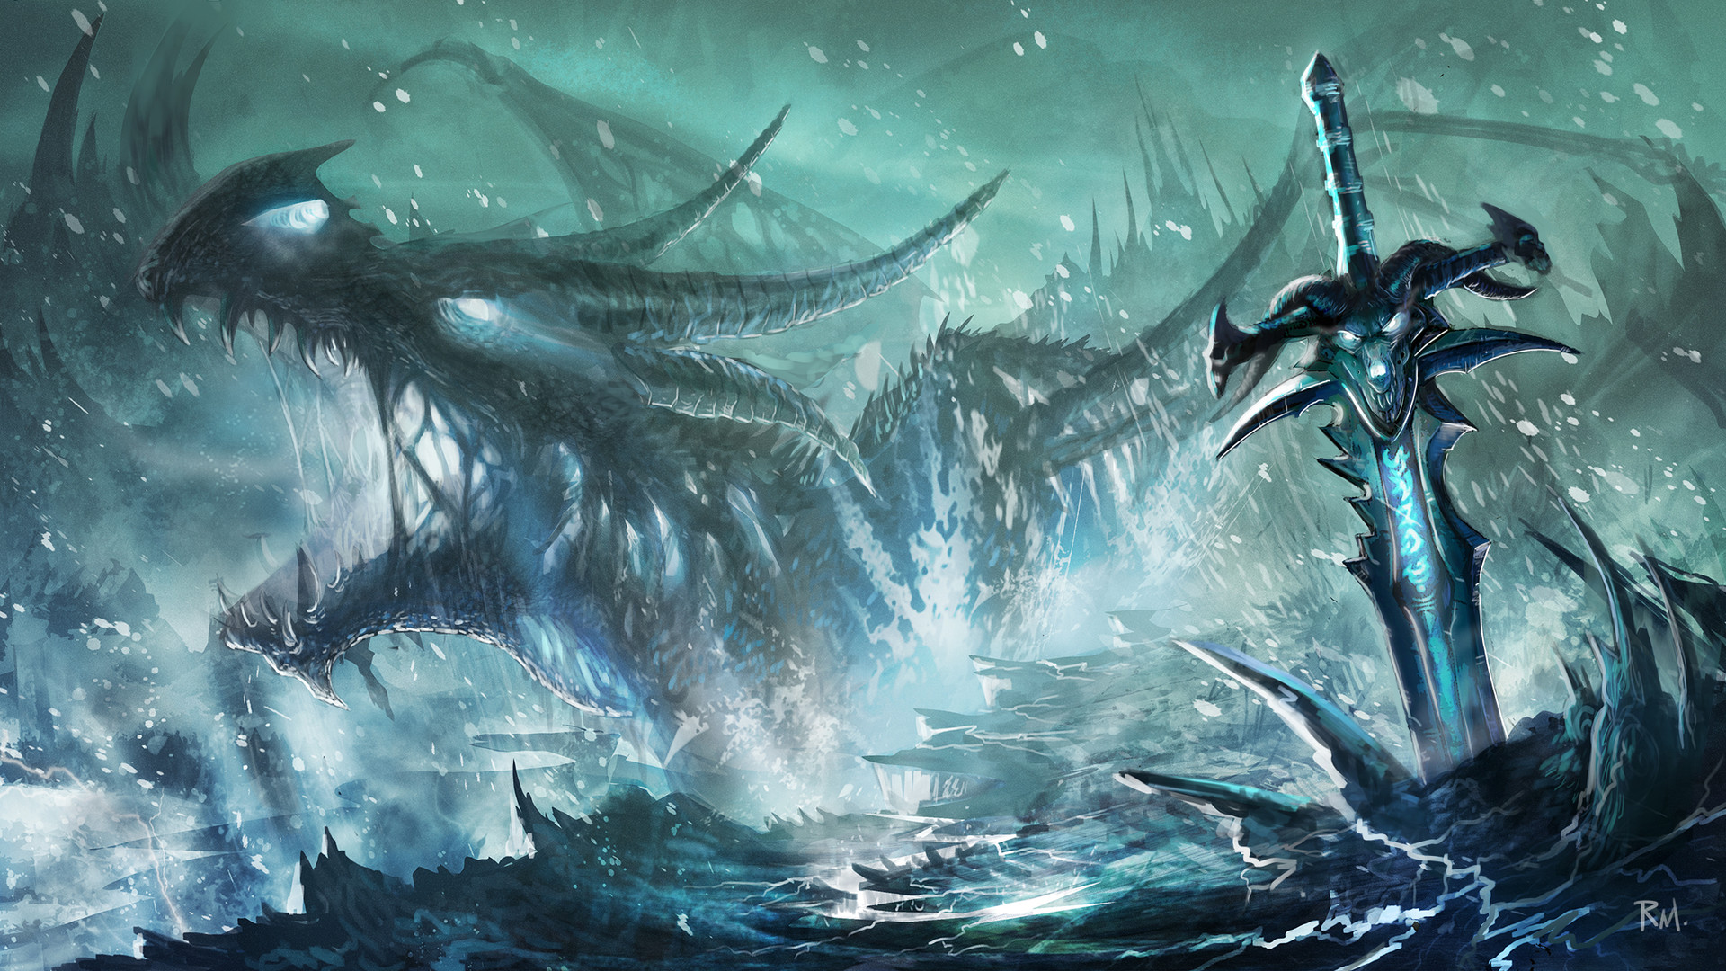

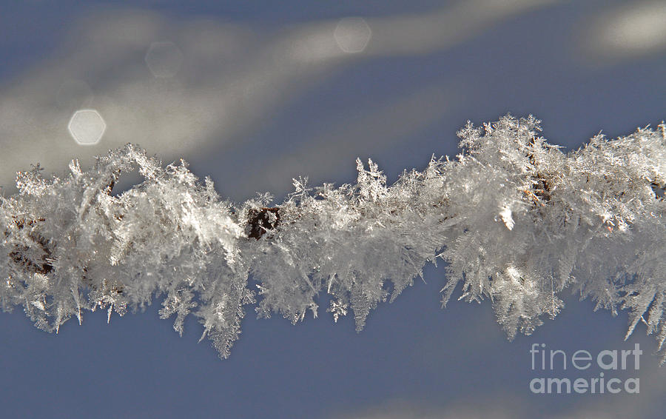

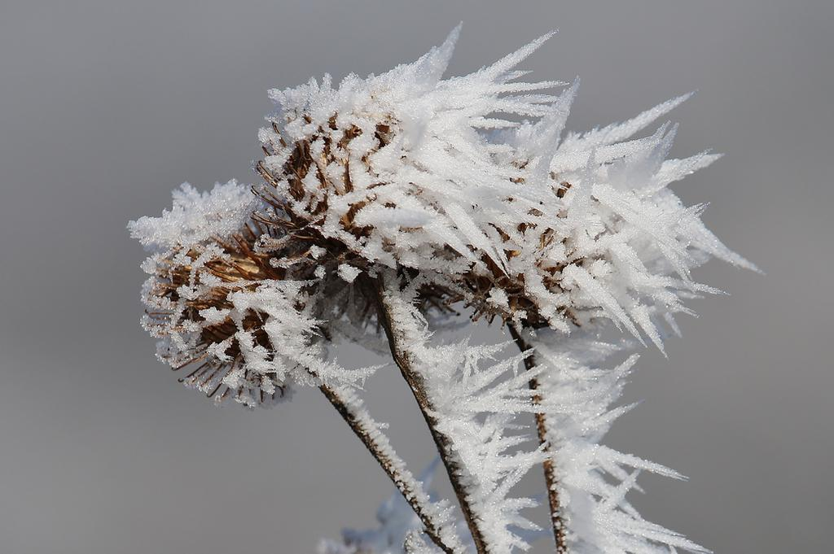

<https://www.youtube.com/watch?v=LfUUrLPorWc>

-Fog effects for unity. Jack suggested we could change the effect to be limited around the lich-

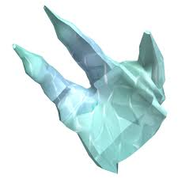 Very basic idea for lich hands?

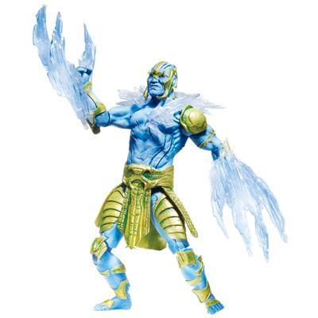 Another example for ice claws?

Rubus strigosus? (North American raspberry bush) For Lich’s plant?

Rubus idaeus(European raspberry bush)  
  
**Lich Ossa Amet (raspberry bones)**

### 

#### Plant: Rubus strigosus

#### Concept:

Ossa Amet literally means Raspberry Bones is a magical creature of the deep cold forests of the far north. These creatures are long-lived as they can die and come back from the harshest of conditions. Ossa Amet is a magical variety of Rubus Strigosus the Wild Raspberry. When a Raspberry grows in an innately magical place it may upon its abscission for winter, it regrows as Ossa Amet a massive and mobile Magical Creature with skin like Raspberry Bark that can better survive the cold winters of a Magical Forest.

The domesticated Lich is grown from Shoot of an Ossa Amet and cannot be replicated from a domestic Lich; for the power of a Necromancers, lich comes from the original creature and its connection to Nature. Finding one in the wild and collecting a sample is difficult and a rare accomplishment for even the most experienced Necromancer.